Generic Bubble Sort Using the Comparable and Comparator Interfaces
Module 6 Programming Assignment

Zachary White
College of Science and Technology, Bellevue University
CSD 420: Advanced Java Programming
Darrell Payne
September 10, 2026

Generic Bubble Sort Using the Comparable and Comparator Interfaces
Overview
This assignment implements two generic bubble sort methods in Java: one that sorts elements using the Comparable interface, and one that sorts elements using the Comparator interface. The implementation follows the bubble sort algorithm and generic method structures described in Liang (2023), as well as the requirements outlined in the Module 6 course materials (Bellevue University, 2026). This paper describes how the application is structured, how data flows through each method when it runs, and how the accompanying test class verifies that both sorting approaches work correctly. Console output from running the test class is included as supporting evidence.
Project Structure
The solution is made up of three files:
- BubbleSort.java | contains two generic sort methods.
- Employee.java | a small custom class implementing Comparable, used to demonstrate the methods on a user-defined type.
- BubbleSortTest.java | A driver class with six tests that exercise both sort methods and print pass/fail results.
How the Comparable Sort Works
The first method accepts an array of any type T, as long as T implements Comparable<T>, consistent with the generic bounded-type approach described by Liang (2023). Because the elements themselves know how to compare to one another, the method calls compareTo() on adjacent elements. This means the same method can sort Integers, Strings, or any custom class, such as Employee, without additional code, as long as that class defines its own natural ordering.
public static <T extends Comparable<T>> void sort(T[] array) {
...
for (int i = 0; i < n - 1; i++) {
swapped = false;
for (int j = 0; j < n - 1 - i; j++) {
if (array[j].compareTo(array[j + 1]) > 0) {
T temp = array[j];
array[j] = array[j + 1];
array[j + 1] = temp;
swapped = true;
}
}
if (!swapped) break;
}
}
On each pass, the inner loop walks through the unsorted portion of the array comparing neighbors. If array[j].compareTo(array[j + 1]) returns a positive number, array[j] is considered greater than array[j + 1], so the two elements are swapped. The largest remaining value bubbles to the end of the array with every pass, which is why the inner loop's upper bound shrinks by one each iteration (n - 1 - i). The swapped flag allows the method to exit early once a full pass makes no swaps, since that indicates the array is already sorted.

How the Comparator Sort Works
The second method uses the same bubble sort logic, but delegates the comparison to an external Comparator<T> object supplied by the caller rather than calling compareTo() on the elements. This approach is useful when objects do not implement Comparable, or when the objects should be sorted in a different order than their natural one, for example sorting Employee objects by salary even though their natural ordering, defined in Employee.compareTo(), is by name.
public static <T> void sort(T[] array, Comparator<T> comparator) {
...
for (int i = 0; i < n - 1; i++) {
swapped = false;
for (int j = 0; j < n - 1 - i; j++) {
if (comparator.compare(array[j], array[j + 1]) > 0) {
T temp = array[j];
array[j] = array[j + 1];
array[j + 1] = temp;
swapped = true;
}
}
if (!swapped) break;
}
}

The only functional difference from the Comparable version is the comparison call itself, comparator.compare(a, b) instead of a.compareTo(b). Every other part of the algorithm, including the swap logic, the shrinking inner bound, and the early-exit optimization, remains identical. This illustrates a key idea from Liang (2023): the bubble sort algorithm itself does not depend on how two elements are compared, only on what the comparison result means.
Example: Sorting Employees Two Different Ways
To demonstrate that the two methods behave differently, the test class sorts the same array of Employee objects twice. The first pass uses the Comparable version, which relies on Employee's natural ordering, alphabetical by name:
public class Employee implements Comparable<Employee> {
private String name;
private double salary;
...
@Override
public int compareTo(Employee other) {
return this.name.compareTo(other.name);
}
}
The second pass sorts the same array using a Comparator defined inline that compares by salary instead:
Comparator<Employee> bySalary = new Comparator<Employee>() {
@Override
public int compare(Employee a, Employee b) {
return Double.compare(a.getSalary(), b.getSalary());
}
};
BubbleSort.sort(employees, bySalary);
The output confirms the difference: the Comparable pass produces Amy, Beth, Mike, Zach (alphabetical), while the Comparator pass produces Mike, Zach, Amy, Beth (lowest to highest salary), from the same starting array.
Test Flow
BubbleSortTest.main() calls six private test methods in sequence, each independent of the others:
- Test 1 | Integers sorted with the Comparable method.
- Test 2 | Strings sorted alphabetically with the Comparable method.
- Test 3 | Strings sorted by length with a Comparator.
- Test 4 | Employees sorted by name with the Comparable method.
- Test 5 | Employees sorted by salary with a Comparator.
- Test 6 | Edge cases: an empty array, a single-element array, and a null array, none of which should throw an exception.
Each test prints the array before and after sorting, then checks the result with a helper method, either isSortedAscending() or an inline comparison loop, and prints a pass or fail result. This provides immediate, readable evidence that each sort behaved as expected without requiring a separate testing framework.
private static <T extends Comparable<T>> boolean isSortedAscending(T[] array) {
for (int i = 0; i < array.length - 1; i++) {
if (array[i].compareTo(array[i + 1]) > 0) {
return false;
}
}
return true;
}

Program Output
The figure below shows the program being compiled with javac and run with java from the command line, followed by the full console output of all six tests. Every test reports a pass result, confirming that both the Comparable and Comparator bubble sort methods sort correctly, including on edge cases.
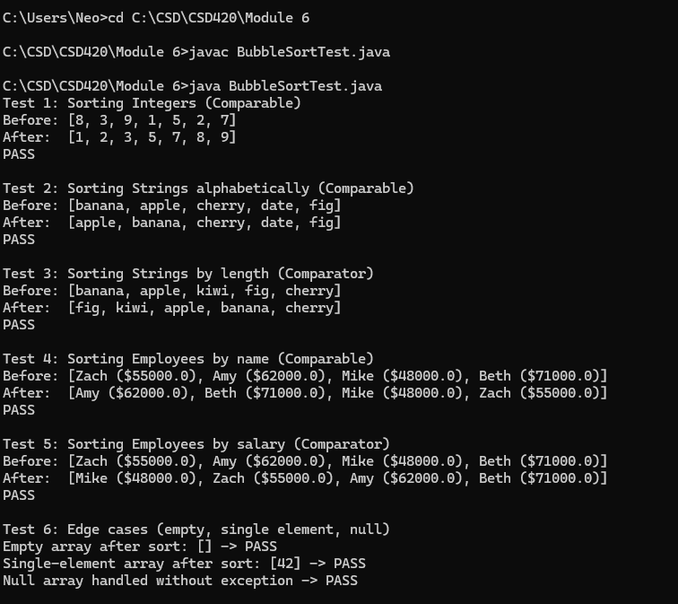
Figure 1. Compilation and console output of BubbleSortTest.java.

Conclusion
This assignment demonstrates two complementary ways to generalize sorting in Java, both grounded in the generic programming concepts presented by Liang (2023) and the requirements of the Module 6 assignment (Bellevue University, 2026). The Comparable-based method keeps sorting logic close to the data type, which works well when a class has one obvious natural order. The Comparator-based method separates sorting logic from the data type entirely, which is useful for sorting by alternate criteria or for types that do not define their own ordering. Both methods share the same underlying bubble sort algorithm, and the test results confirm that both implementations sort a variety of data types correctly, including edge cases.

References
Bellevue University. (2026). Module 6: Sorting algorithms and generic methods [Course materials]. CSD 420: Advanced Java Programming. Blackboard. https://bellevue.edu
Liang, Y. D. (2023). Introduction to Java programming and data structures (13th ed.). Pearson.

